|  |  |
| --- | --- |
| Industry Assignment  ITRI 614 | Enrico Dreyer  31210783 |

Table of Contents

Table of Figures 1

Introduction 2

Project management methodologies 2

What is a project management methodology? 2

Agile Methodology 2

Benefits of using this methodology 3

Good practices 3

Kanban Methodology 3

Benefits of using this methodology 4

Six Sigma Methodology 4

Define 5

Measure 5

Analyze 5

Improve 5

Control 5

Waterfall Methodology 6

Requirements 6

Design 6

Implementation 6

Verification or Testing 6

Deployment and maintenance 7

COBIT 7

Five principles of COBIT 7

Conclusion 8

References 9

# Table of Figures

Figure 1: SCRUM Process 3

Figure 2: KanBan Board 4

Figure 3: DMAIC 5

Figure 4: Waterfall Stages 6

Figure 5: COBIT Principles 8

# Introduction

In this article, we will be discussing the most applicable project management methodologies over the course of the next couple of years. We take into consideration the requirements of external and internal clients as well as the forces that they represent. We debate on why portfolios, programs, organizations, and project managers should take note and should manage, plan, and cater to make the most out of their opportunities, and minimize the threats associated with the project management methodologies that are going to be discussed in this article.

The focus of this article will not only be on the current and future project management methodologies, but also bodies of knowledge and governance framework. The main idea is to deliver a project on time, according to budget, and in scope.

# Project management methodologies

Companies need to be more efficient and effective to improve and maintain their activities in the business considering the challenges that they face in the business environment. Businesses cannot avoid change, no matter how successful they have been in the past. Failing in planning and using a project management methodology may lead to a business going down.

The PMBOK Guide (Guide, A., 2001) states that a methodology is a system of procedures, rules, techniques, practices used by those that work in the discipline.

According to ProjectCubicle (Scorlot, 2018) Lean, Agile, Kanban, Waterfall, and Six Sigma are some examples of project management methodologies and will be explained further in the article.

# What is a project management methodology?

Project managers use different techniques, methods, and tools to complete a project successfully. Most of the time they apply different frameworks, systems, principles, and processes together to deliver a project to both meet the requirements and to be on time.

They choose the best and most suitable methodology to support the organizational structure and project conditions. In today’s economic environment, projects require more technology and require more resources than collaboration.

## Agile Methodology

This methodology gives an iterative, flexible design and building process. Agile provides more than just a methodology, it includes a set of processes for comprehensive projects in environments that are constantly changing.

According to Stackify (ALTVATER, 2017) Agile was designed to overcome the old waterfall way of programming, which caused a project to fail after years because of something that happened in the early stages of the project. The waterfall worked when making buildings or cars but not as well for creating systems, where the demand is always changing.

An overview of this methodology is creating smaller phases of the project called sprints. Where it looks to deploy a draft in the first sprint and a piece of software in the first couple of months.

Feedback is needed from the customer on a daily basis, to ensure that the project is on track.

The most common and popular example of this methodology includes SCRUM, Feature Driven Development (FDD), Dynamic Systems Development Method (DSDM) and Crystal.

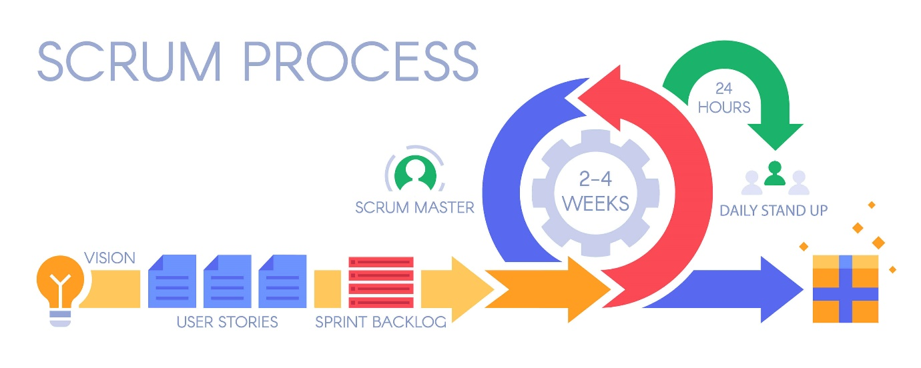

Figure : SCRUM Process

### Benefits of using this methodology

A faster way of developing software and having a faster life cycle means that there is less time between getting paid and paying for software that you use. Because you have constant communication with your customer it increases customer satisfaction and customers can start using part of the system and decide on what they want first.

### Good practices

* Set priorities, such as having a backlog
* Have 2-to-4-week sprints
* Pair program when necessary
* Refactor your code
* Use test-driven development, like have a UAT

## Kanban Methodology

This methodology has Lean principles and focuses on increasing productivity by getting rid of wasted time and resources. This methodology can be used alongside Agile.

According to Inflectra (Inflectra, n.d.), in the process Kanban, there are cards that move from start to finish, with the intention of keeping an orderly flow between the processes and what needs to be done and what is finished. Kanban uses the stages of the software development lifecycle for the different stages of the manufacturing process.

Kanban allows the team to develop software in a large development cycle, unlike SCRUM that uses short cycles. While the principles behind Kanban allow it to be Agile and incremental, it is limited throughput.

A Kanban project with no iterations has no way of defining the start or endpoints when looking at individual items in the project. Every task can start or end without affecting the other tasks.

When using Kanban in your project you have “Working In Progress” that measures the capacity that focuses the development team on only small amounts of work at a time. Only when that one task is completed may a new task be pulled into the cycle.

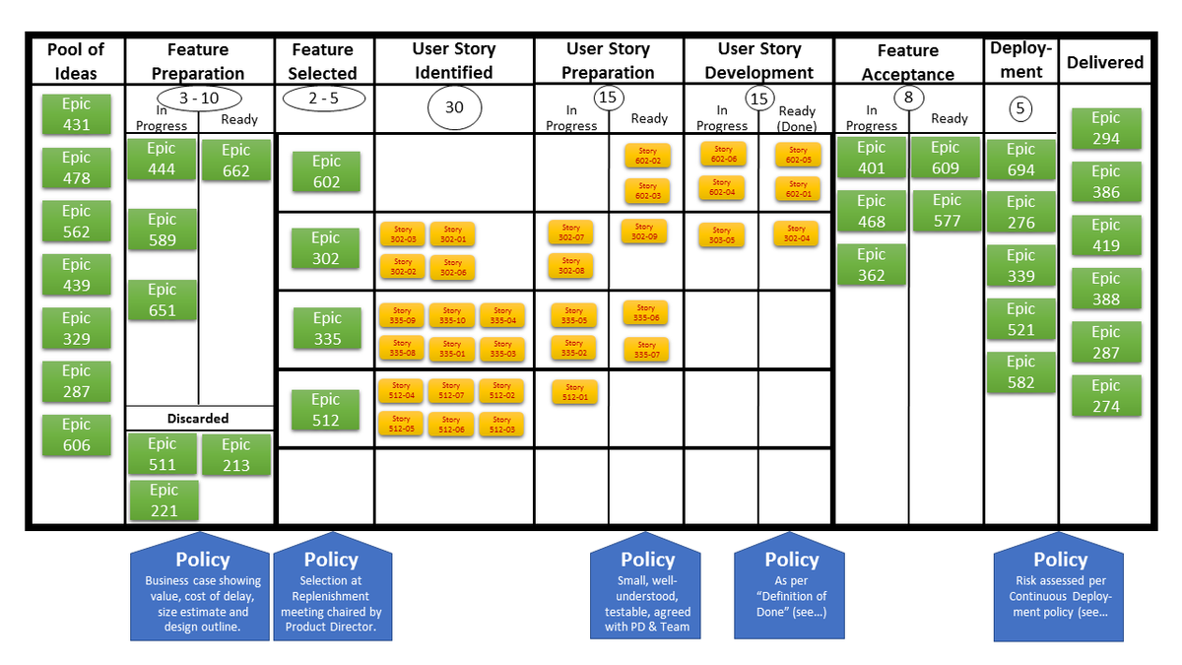

Figure : KanBan Board

### Benefits of using this methodology

The key benefit of this methodology is that continuous improvement is central and that improves the flow of work that is being done on the project.

When your project needs automated testing Kanban can fully integrate with your development process and can adapt to your changing needs. When you use the automated testing process it can improve consistency and repeatability.

## Six Sigma Methodology

This methodology is a problem-solving technique that is very useful for the improvement of a process. Six Sigma relies on five process steps that are called DMAIC.

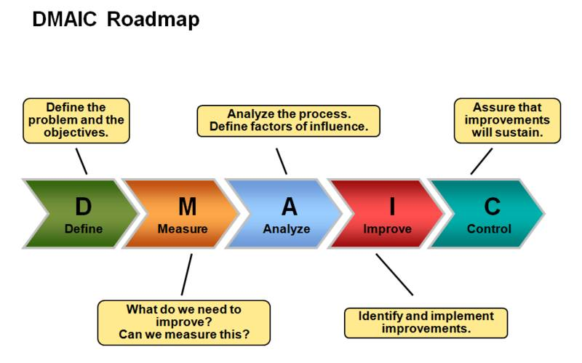

Figure : DMAIC

According to GreyCampus (Rastogi, 2018), DMAIC forms part of one of the Lean Six Sigma processes but can be used as a standalone process to improve quality.

### Define

The objective of this phase is to gather all of the information of the project plan and make a summary of it. The phase is there to clarify the goals, problems, scope, requirements, and who the customers are.

### Measure

This phase has the main objective of collecting data that is relevant to the project and the scope. Identifying the parameters and the ways of collecting them are one of the main focuses of this phase.

### Analyze

In this phase, it is important to find the main cause of business inefficiency. It is there to identify the gaps between goal and actual performance and to identify what causes the gap and improve on the opportunities given.

### Improve

This phase is there for the company to determine potential solutions, the ways to use them to their advantage, to test these solutions, and implement them to improve their project. Process owners in this phase are consulted and suggest an improvement.

### Control

In this phase, it is important to make a detailed solution monitoring plan. This plan that was made is to ensure that the performance that is required is maintained. It validates and defines the monitoring system, verifies profit growths, and benefits, develops procedures and standards, and it also communicates to the business.

## Waterfall Methodology

This methodology is an uncomplicated method for planning a project. In this methodology, the whole team completes one task, then proceeds to the next task or step. All requirements, activities, and features are defined at the beginning of the project.

According to Workfront (Company, n.d.), there are five common stages in the waterfall methodology, shown in “Figure 4: Waterfall Stages”

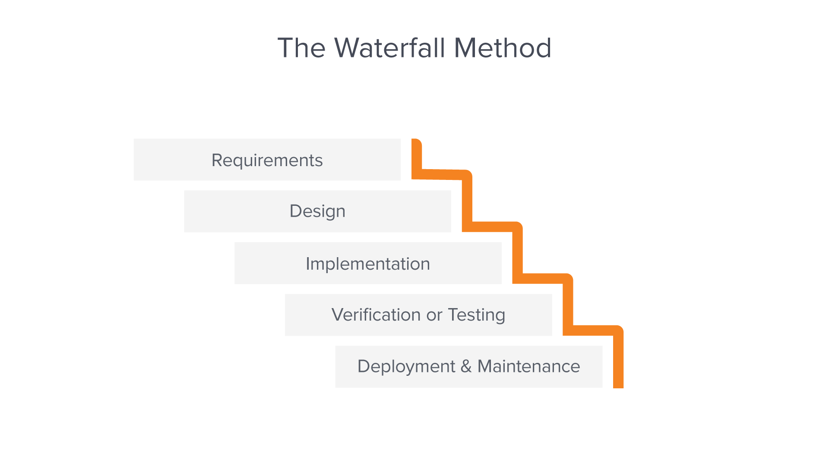

Figure : Waterfall Stages

### Requirements

In the waterfall methodology, it is believed that all requirements can be collected and understood at the beginning of the project. Requirements are written and most of the time it is a single document that is used to give a layout of every stage of the project. This includes the assumptions, costs, success metrics, dependencies, risks, and the time that the project needs to be finished.

### Design

In this phase of the project, a technical solution is designed by the software developers to solve the project requirements, this includes layout, data models, and scenarios.

A logical or higher-level design is first created to describe the scope and purpose of the project. Then that is completed, they change that into a physical design using their specific software and hardware technologies.

### Implementation

This is where the software developers use the project specifications and requirements to code the application. If changes are made in this stage, it is needed to go back to the design phase.

### Verification or Testing

This stage is needed because testing is needed before releasing the project to the customers. This ensures that the product has no bugs, good user experience, and all the requirements have been met.

### Deployment and maintenance

After deploying the software, the maintenance phase starts. As bugs arise and changes are requested by the users there will be a team to ensure that new releases, updates, and versions of the software come out.

## COBIT

This is a framework, and it defines a set of common processes that the management of IT can follow. Each phase defines key process activities, input and outputs, process objectives, one elementary maturity model, and performance measures (Haes, 2016).

### Five principles of COBIT

**Meeting stakeholder needs**, this brings in the factor that you create value for your customer when doing anything in the project. You always need to consider what the customer benefits from your decisions.

**Covering the enterprise end-to-end** implies making decisions that are not only going to infect the company but also decisions that hold forth past the IT functions. Treat IT like an asset that is just as important as other processes.

**Applying a Single, Integrated Framework**, allows the framework to not only be used in your project but as an overarching governance instrument to manage systems wherever it is relevant.

**Enabling a Holistic Approach** implies that you should not look to view a system as individual parts but as a whole.

**Separating Governance From Management** emphasizes that there is a clear distinction between management and IT governance and that they need different processes as they have separate organizational purposes.

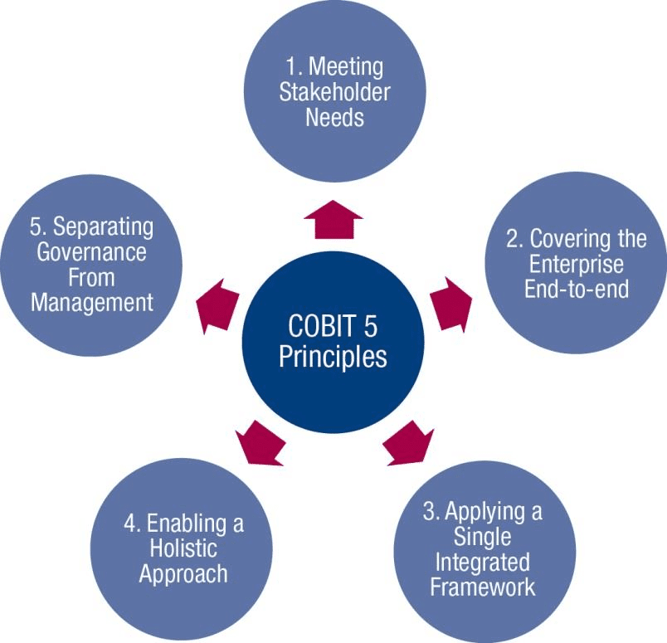

Figure : COBIT Principles

# Conclusion

In this paper, we looked at different and most applicable project management methodologies and bodies of knowledge to be used when taking into consideration the requirements of external and internal clients.

When using a project management methodology, provides a lot of advantages to a company. It is there to improve knowledge management and sustainability and when the wrong methodology is chosen it has the opposite effect and can bring a project down.

All methodologies are not applicable to all projects and organizations, when looking at the construction industry, the waterfall methodology is more useful than the others, but when looking in the software industry, an Agile approach a better option because of the constant change.

It all depends on what project you want to start and understanding each methodology will help you to become more successful in the field of project management

# References

ALTVATER, A. (2017, September 17). *What is Agile Methodology? How It Works, Best Practices, Tools*. Retrieved from stackify: https://stackify.com/agile-methodology/#:~:text=%20Benefits%20of%20Agile%20Methodology%20%201%20Faster.,more%20productive%20than%20those%20who%20are...%20More%20

Company, A. A. (n.d.). *Waterfall Methodology*. Retrieved from What is the Waterfall methodology?: https://www.workfront.com/project-management/methodologies/waterfall#:~:text=What%20is%20the%20Waterfall%20methodology%3F%20The%20Waterfall%20methodology%E2%80%94also,completely%20wrapping%20up%20before%20the%20next%20phase%20begins.

Inflectra. (n.d.). *What is Agile Kanban Methodology?* Retrieved from Inflectra: https://www.inflectra.com/Methodologies/Kanban.aspx#:~:text=Kanban%20is%20an%20agile%20methodology%20that%20is%20not,software%20be%20developed%20in%20one%20large%20development%20cycle.

Rastogi, A. (2018, March 13). *DMAIC – A Six Sigma Process Improvement Methodology*. Retrieved from GreyCampus: https://www.greycampus.com/blog/quality-management/dmaic-a-six-sigma-process-improvement-methodology#:~:text=Six%20Sigma%20is%20a%20measurement-based%20strategy%20for%20process,leads%20to%20consistent%20and%20desired%20outcomes%20from%20processes.

Scorlot, B. (2018, March 30). *Project Management Methodologies*. Retrieved from ProjectCubicle: https://www.projectcubicle.com/project-management-methodologies/#:~:text=Failing%20to%20use%20a%20project%20management%20methodology%20may,Waterfall%20are%20the%20examples%20of%20project%20management%20methodologies.

Guide, A., 2001. Project management body of knowledge (pmbok® guide). In *Project Management Institute*.

Haes, S.D.; Grembergen, W.V. (2015). ["Chapter 5: COBIT as a Framework for Enterprise Governance of IT"](https://books.google.com/books?id=zNgRBwAAQBAJ&pg=PA102). *Enterprise Governance of Information Technology: Achieving Alignment and Value, Featuring COBIT 5* (2nd ed.). Springer. pp. 103–128. [ISBN](https://en.wikipedia.org/wiki/ISBN_(identifier)) [9783319145471](https://en.wikipedia.org/wiki/Special:BookSources/9783319145471). Retrieved 24 June 2016.